**Turdalin Nurassyl LAB2**

**3.5.5**

**Part 1**

1. Did anything change? – Web page appeared, it means we take page form server.
2. What information is listed in the numbered steps directly below the In Layers and Out Layers boxes for Layer 7? - The HTTP client receives a HTTP reply from the server. It displays the page in the web browser.
3. What is the Dst Port value for Layer 4 under the Out Layers column? – 80
4. What is the Dest. IP value for Layer 3 under the Out Layers column? – 192.168.1.254
5. What information is displayed at Layer 2 under the Out Layers column? - Layer 2 Ethernet II Header and inbound and outbound MAC addresses.
6. What is the common information listed under the IP section of PDU Details as compared to the information listed under the OSI Model tab? With which layer is it associated? - SRC IP and DST IP at Layer 3
7. What is the common information listed under the TCP section of PDU Details, as compared to the information listed under the OSI Model tab, and with which layer is it associated? - SRC PORT and DEST PORT at Layer 4
8. What is the Host listed under the HTTP section of the PDU Details? What layer would this information be associated with under the OSI Model tab? - www.osi.local, Layer 7
9. Comparing the information displayed in the In Layers column with that of the Out Layers column, what are the major differences? - The Src and Dst Ports, Src and Dst IPs and MAC addresses have been swapped.
10. How many tabs are displayed with this event?   
    Just 2, one for the OSI Model and one for Inbound PDU Details because this is the receiving device.  
    **PART 2**
11. What additional Event Types are displayed? – 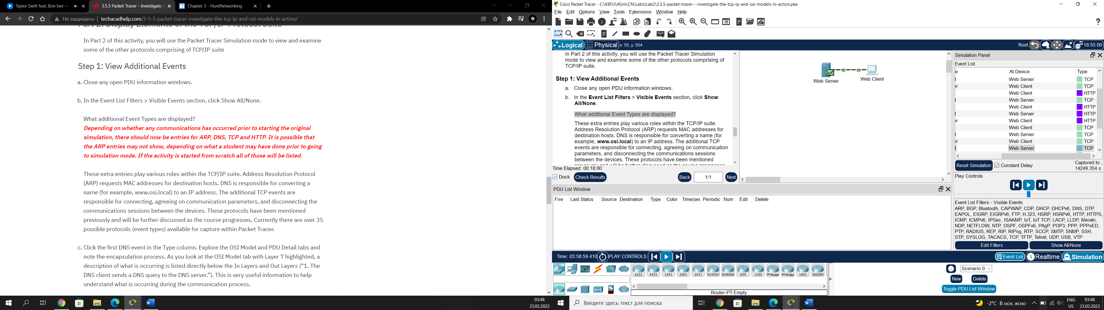
12. What information is listed in the NAME field: in the DNS QUERY section? - - NAME (VARIABLE LENGTH):www.osi.local
13. At which device was the PDU captured? - The Web Client
14. What is the value listed next to ADDRESS: in the DNS ANSWER section of the Inbound PDU Details? – the address of web server. In our case it’s 192.168.1.254

RESULT: 